|  |
| --- |
| **Lab 1 Overview Power BI Desktop Transformations** |

## SCENARIO

VanArsdel is a company that manufactures and sells sporting goods. The company has offices in the United States (US) and several other countries. Its sales comprise of US sales and International sales. VanArsdel’s sales come from its owned manufactured products, as well as other manufacturers’ products.

VanArsdel's US office stores the sales data on an Access database. VanArsdel International sales transactions are available as comma separated (CSV) files. They could be generated daily, either manually by someone, or automatically by an automated process. They are available in a dedicated folder. These CSV files have the same column structure as the sales table for the US sales that comes from the SQL Database.

You want to perform analysis on VanArsdel's worldwide sales data for the year 2000 to 2015. You need to bring all these data into Power BI Desktop before you can perform any analysis. Finally, you want to compare VanArsdel's country sales with the country population. You need to import the country population data from a less structured Excel report to Power BI.

## LAB OVERVIEW

This lab comprises of three exercises:

1. In the first exercise, you will import data to Power BI Desktop from an Access database file.
2. In the second exercise, you will import data from CSV files which resides in a file folder. You will append this new data to the corresponding existing data that comes from the Access Database.
3. In the third exercise, you will import data to Power BI Desktop from an Excel file that is less structured.

Before starting this lab, you should review the Power BI Desktop Data Transformations module in this course. Then, if you have not already done so, follow the instructions in the Set up the Lab Environment section of this course to set up the lab environment.

## WHAT YOU'LL NEED

* A computer with the latest version of Power BI Desktop installed on it.
* A copy of the [Access Database](https://github.com/MicrosoftLearning/Analyzing-Visualizing-Data-PowerBI/raw/master/Lab1/PowerBI%20AccessDB.zip) containing VanArsdel's US sales data.
* 4 CSV files, containing VanArsdel’s [international sales](https://github.com/MicrosoftLearning/Analyzing-Visualizing-Data-PowerBI/raw/master/Lab1/InternationalSales.zip) data:
  + CA Sales.csv
  + FR Sales.csv
  + DE Sales.csv
  + MX Sales.csv
* An Excel file containing [country population](https://github.com/MicrosoftLearning/Analyzing-Visualizing-Data-PowerBI/raw/master/Lab1/CountryPopulationByYear.zip) data.
* **NOTE:** If you are having issues with the direct link, head over to the github repository and download from there. <https://github.com/MicrosoftLearning/Analyzing-Visualizing-Data-PowerBI>

# CONNECTING TO AN ACCESS DATABASE FOR THE FIRST TIME

If you are connecting to an Access database for the first time, you might need to install the Access redistributable package.

* If you have a 32 bit machine, you need to install the 32 bit Power BI Desktop and the 32 bit redistributable of Access.
* If you have a 32 bit Office installed (regardless of your machine), you need to install the 32 bit Power BI Desktop and the 32 bit redistributable of Access.
* Otherwise, you can install the 64 bit Power BI Desktop and the 64 bit redistributable of Access.

Follow the link provided by Power BI Desktop when trying to connect to the Access database.

|  |
| --- |
| Lab 1.Exercise 1: Import Data from Access Database |

VanArsdel's US office stores the sales data on an Access database. You will need to perform analysis on that data, but before you can do so, you need to import the data to Power BI Desktop and perform some transformations.

**IMPORTANT!** Before you start, if your locale settings is not English (United States), you might want to change this, since the data you will import is based on this locale. This is covered in "[Changing Locale](https://courses.edx.org/courses/course-v1:Microsoft+DAT207x+4T2016/jump_to_id/55f1d106646e45ff8cc89591f293ac04)".

1. Download and extract the VanArsdel's [Access database](https://github.com/MicrosoftLearning/Analyzing-Visualizing-Data-PowerBI/raw/master/Lab1/PowerBI%20AccessDB.zip). **NOTE:** If you are having issues with the direct link, head over to the github repository and download from there. <https://github.com/MicrosoftLearning/Analyzing-Visualizing-Data-PowerBI>
2. Start with a blank Power BI Desktop file.
3. Connect to the Access database by using **Get Data** and select the Access database file.
4. Select the following tables to be imported: **bi_date**, **bi_geo**, **bi_manufacturer**, **bi_product**, and **bi_salesFact**.
5. Edit the query before loading to the data model.
6. Filter the rows on the **bi_salesFact** query to include dates from January 1st, 2000. (Hint: Apply a **Date filter** in the **Date** column to import dates after December 31st, 1999. Before you can apply a date filter, you need to change the **Date** column's **Data Type** to **Date**).
7. Filter the rows on the **bi_date** query to include dates from January 1st, 2000. (Hint: Apply a **Date filter** in the**Date** column to import dates after December 31st, 1999. Before you can apply a date filter, you need to change the **Date**column's **Data Type** to **Date**).
8. Rename the queries as follows:
   * bi_date: **Date**
   * bi_geo: **Locations**
   * bi_manufacturer: **Manufacturers**
   * bi_product: **Products**
   * bi_salesFact: **Sales**
9. Load the data into Power BI Desktop. This might take a few minutes.
10. Explore the imported data in the **Data**View.

|  |
| --- |
|  |

# Lab 1.Exercise 2: Import Data from a Folder Containing CSV

Continue with your Power BI file from the previous exercise. You want to create a Query for the International sales and append the Query to the Query from US Sales.

1. Download the [zip file](https://github.com/MicrosoftLearning/Analyzing-Visualizing-Data-PowerBI/raw/master/Lab1/InternationalSales.zip) containing VanArsdel's international sales data and extract it to a folder. You should see 4 CSV files in the folder.
2. Import the data from the file folder by using the **Get Data**. To do this, click the**Get Data / More** option, select **Folder** and click **Connect**. Select the folder where you saved the 4 CSV files containing VanArsdel’s international sales data.
3. Perform the following steps:
   * Name the query **International Sales**.
   * Select to combine (combined binaries) the content of those 4 files.
   * Filter the rows that come from the header of the CSV files. (Hint: One way to do this is to filter out the **Country**column from records containing “Country”).
   * Filter the rows that are after **December 31st, 1999**.
4. Edit the **Sales** Query from the US Sales.
5. Append the **International Sales** Query to the **Sales** query from the US Sales.
6. In the **Sales** query, add a custom column named **Country Name**which takes the value of the **Country**column when it is not null and the value of "USA" when the **Country** column is null.
7. Remove the **Country** column.
8. Load the data into Power BI Desktop. This might take a few minutes.
9. Explore the imported data in the **Data**View.
10. Hide the **International Sales** table from report view.

|  |
| --- |
|  |

# Lab 1. Exercise 3: Import a Less Structured Data from an Excel File

Continue with your Power BI file from the previous exercise. You want to import an Excel report containing population data for the countries that VanArsdel operates.

1. Download the [zip file](https://github.com/MicrosoftLearning/Analyzing-Visualizing-Data-PowerBI/raw/master/Lab1/CountryPopulationByYear.zip) containing the Country Population data. (Data is a subset of the "World Data Bank's Population, total" dataset). Extract the file to "C:\DAT207x".
2. Import the data from the file folder by using the **Get Data**. To do this, click the**Get Data / Excel**option. Select the Excel file containing the Country Population data.
3. Edit the query and perform the following steps:
   * Name the Query **Country Population**.
   * Remove the first four rows of the table.
   * Promote the row that represents the title of the column to the table headers.
   * Transform the yearly columns to rows and name the resulting columns appropriately. (Hint: You might find the **Unpivot Columns** feature useful).
   * Rename the resulting columns to **Year** and **Population** respectively.
   * Filter out the year **1999**.
   * Set the **Data Type** of both the **Year** and **Population** columns to **Whole Number**.
4. Load the data into Power BI Desktop.
5. Explore the imported data in the **Data**View.

|  |
| --- |
| Lab 2 Overview Power BI Desktop Modeling |

## SCENARIO

VanArsdel is a company that manufactures and sells sporting goods. The company has offices in the United States (US) and several other countries. Its sales comprise of US sales and International sales. VanArsdel’s sales come from its owned manufactured products, as well as other manufacturers’ products.

You have successfully brought the US sales data from the Access database and the International sales data from a collection of CSV files to Power BI Desktop. Before you can start analyzing your data, you need to manage the table relationships within your data model and create new ones if necessary. To do so, you might need to create calculated columns or calculated tables for the relationships to be based on.

Once you have all the relationships created, you can create visualizations and start to analyze the data. However, you need to create additional measures to perform more advanced analysis with your data, which includes:

* Comparing last year sales and last year YTD sales.
* Comparing sales of VanArsdel's manufactured goods to other manufacturers.

## LAB OVERVIEW

In this lab, you will create calculated columns, calculated tables, and create table relationships in your data model based on the calculated columns and tables you created. In addition, you will write several DAX expressions to create measures to be used to analyze VanArsdel’s sales data. Specifically, you will create the following measures:

* **Total Sales**: calculates the total sales.
* **LY Sales**: calculates last year sales.
* **Sales Var**: calculates sales variance between this year and last year sales.
* **Sales Var %**: calculates sales variance between this year and last year sales in percentage.
* **YTD Sales**: calculates YTD sales.
* **LY YTD Sales**: calculates last year YTD sales.
* **YTD Sales Var**: calculates sales variance between this year and last year YTD sales.
* **YTD Sales Var %**: calculates sales variance between this year and last year YTD sales in percentage.
* **Total VanArsdel Sales**: calculates sales for VanArsdel manufactured goods.
* **% Sales Market Share**: calculates the percentage of VanArsdel manufactured goods from the total sales.

Before starting this lab, you should review the **Power BI Desktop Modelling** module in this course. Then, if you have not already done so, follow the instructions in the **Set up the Lab Environment** section of this course to set up the lab environment.

## WHAT YOU’LL NEED

* A computer with the latest version of Power BI Desktop installed on it.
* The following Power BI Desktop file:
* The “[Lab 2 - Starting.pbix](https://github.com/MicrosoftLearning/Analyzing-Visualizing-Data-PowerBI/blob/master/Lab2/Lab%202%20-%20Starting.zip?raw=true)” file

# Lab 2.Exercise 1: Manage Table Relationships

Power BI Desktop has automatically detected and created table relationships. So the first step is to ensure all the relationships are properly created, and if not, create them yourselves.

1. Start with the "[Lab 2 - Starting.pbix](https://github.com/MicrosoftLearning/Analyzing-Visualizing-Data-PowerBI/blob/master/Lab2/Lab%202%20-%20Starting.zip?raw=true)" file.
2. Open the **Relationship** view.
3. Ensure that there is a many to one relationship with both cross directional filtering from the **ProductID**column on the **Sales** table to the **ProductID**column on the **Products**table. If not, create the relationship by dragging the **ProductID** column on the **Sales** table to the **ProductID** column on the**Products** table.
4. Ensure that there is a many to one relationship with both cross directional filtering from the **ManufacturerID**column on the **Products**table to the **ManufacturerID**column on the **Manufacturers**table. If not, create the relationship.
5. Ensure that there is a many to one relationship with both cross directional filtering from the **Date** column on the **Sales** table to the **Date** column on the **Date** table. If not, create the relationship.

Now you want to create a relationship between the **Sales** table and the **Locations** table. First, you merge the **Country** and **Zip** columns in both **Sales** and **Locations** table as a new column, **CountryZip**. Then, you create a relationship on the **CountryZip**column for both tables.

1. Edit the **Locations**table in the **Data** view.
2. Add a new column named  **CountryZip**by concatenating the value from the **Country** column, a comma and a space character, and the value from the **Zip** column. (Hint: the calculated column formula look as follows: CountryZip = Locations[Country] & ", " & Locations[Zip])
3. Edit the **Sales**table in the **Data** view.
4. Add a new column named  **CountryZip**by concatenating the value from the **Country Name** column, a comma and a space character, and the value from the **Zip** column. (Hint: the calculated column formula look as follows: CountryZip = Sales[Country Name] & ", " & Sales[Zip])
5. Open the **Relationship** view.
6. Link the newly created **CountryZip**column on the **Sales** table to the newly created **CountryZip**column on the **Locations** table.

|  |
| --- |
| Lab 2.Exercise 2: Last Year Comparison |

You want to know how much sales (revenue) in total does the VanArsdel have and to compare this with the figure from the same period last year. You need to create several calculated measures to help with this comparison. To do so, in either the **Report** view or the **Data** view, right-click the **Sales** table, click **New Measure**, and type in the corresponding DAX formulas for the measure you want to create. This will create the measures with the **Home Table** properties set to the **Sales** table.

Specifically, you will create the following measures:

* **Total Sales**: calculates the total sales. Format this measure as **Currency**. (Hint: Check out the **SUM** function).
* **LY Sales**: calculates last year sales. Format this measure as **Currency**. (Hint: You might find the **CALCULATE** and **SAMEPERIODLASTYEAR** function useful).
* **Sales Var**: calculates sales variance between this year and last year sales. Format this measure as **Currency**. (Hint: This is simply the difference between **Total Sales** and **LY Sales**).
* **Sales Var %**: calculates sales variance between this year and last year sales in percentage. Format this measure as **Percentage**. (Hint: This is simply the percentage of **Sales Var** from **LY Sales**. You might find the **DIVIDE** function useful).

|  |
| --- |
| Lab 2.Exercise 3: Year to Date |

Year-to-date (YTD) is a period starting from the beginning of the current year and continuing up to the present date. You want to calculate the YTD sales and compare this with the figure from the same period last year. Specifically, you will create the following measures:

* **YTD Sales**: calculates the YTD sales. Format this measure as **Currency**. (Hint: Check out the **TOTALYTD** function).
* **LY YTD Sales**: calculates last year YTD sales. Format this measure as **Currency**. (Hint: You might find the **CALCULATE** and **SAMEPERIODLASTYEAR** function useful).
* **YTD Sales Var**: calculates sales variance between this year and last year YTD sales. Format this measure as **Currency**. (Hint: This is simply the difference between **YTD Sales** and **LY YTD Sales**).
* **YTD Sales Var %**: calculates sales variance between this year and last year YTD sales in percentage. Format this measure as **Percentage**. (Hint: This is simply the percentage of **YTD** **Sales Var** from **LY YTD Sales**. You might find the **DIVIDE** function useful).

|  |
| --- |
| Lab 2.Exercise 4: Market Share |

VanArsdel’s sales comprise of products manufactured by VanArsdel and other companies. You want to know how much of these sales are VanArsdel’s own manufactured products. You decide to show this share in numbers and %. Specifically, you will create the following measures:

* **Total VanArsdel Sales**: calculates sales where the products manufacturer is VanArsdel. Format this measure as **Currency**. (Hint: Use the **CALCULATE** function and filter by Manufacturer).
* **% Sales Market Share**: calculates the percentage of sales of VanArsdel manufactured products from the total sales. Format this measure as **Percentage**.

|  |
| --- |
| Lab 3 Overview Power BI Desktop Visualization |

## SCENARIO

VanArsdel is a company that manufactures and sells sporting goods. The company has offices in the United States (US) and several other countries. Its sales comprise of US sales and International sales. VanArsdel’s sales come from its owned manufactured products, as well as other manufacturers’ products.

## LAB OVERVIEW

In this lab, you will create several reports using several visualizations in Power BI Desktop.

Before starting this lab, you should review **Power BI Desktop Visualization** module in this course. Then, if you have not already done so, follow the instructions in the **Set up the Lab Environment** section of this course to set up the lab environment.

## WHAT YOU’LL NEED

* A computer with the latest version of Power BI Desktop installed on it.
* The following Power BI Desktop file:
* The “[Lab 3 - Starting.pbix](https://github.com/MicrosoftLearning/Analyzing-Visualizing-Data-PowerBI/raw/master/Lab3/Lab%203%20-%20Starting.zip)” file

|  |
| --- |
| Lab 3.Exercise 1: Cross-Tabular Report |

Let's start with an easy one. You want to show VanArsdel's sales (revenue) and units for each month and year in a single report. You choose to show this using two Matrix visualizations.

1. Start with the "[Lab 3 - Starting.pbix](https://github.com/MicrosoftLearning/Analyzing-Visualizing-Data-PowerBI/raw/master/Lab3/Lab%203%20-%20Starting.zip)" file.
2. Open the **Report** view.
3. Drag the **Total Sales** field from the **Sales** table to the report and create a chart.
4. Drag the **MonthName** and **Year** fields from the **Date** table to the chart.
5. Modify the chart to use the **Matrix** visualization.
6. Arrange so that the month is shown as the rows and the year is shown as the columns of the matrix visualization.
7. Repeat Step 3 to 6, but this time, display the **Total Units** field in the chart.
8. Add a Text Box to the report and enter **VanArsdel Sales and Units** as the text.
9. Rename the report sheet to **Sales and Units.**

You should have something similar to the below:

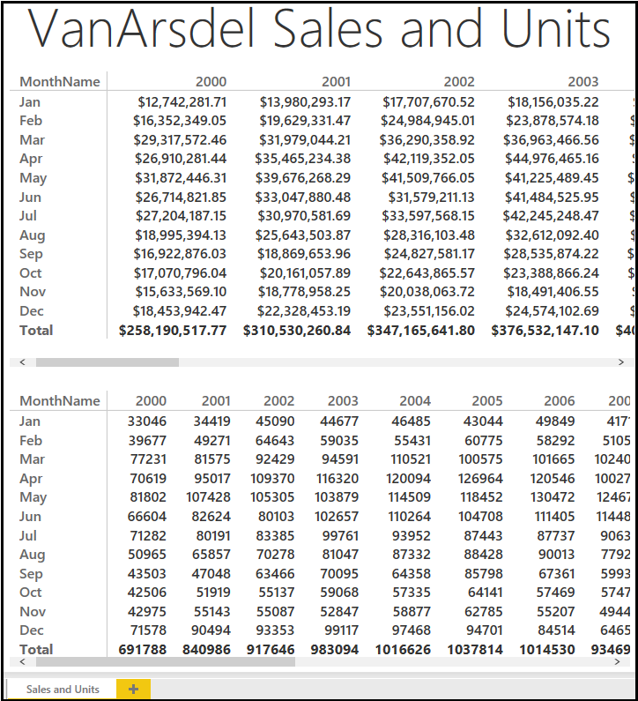

|  |
| --- |
| Lab 3.Exercise 2: Part-to-Whole Report |

Now that you have the big picture, let's start analyzing the data sales data by product category, segment and manufacturer.

1. Create a new report page by clicking the Yellow "+" icon at the bottom of the report view.
2. Drag the **Total Sales** field from the **Sales** table to the report and create a chart.
3. Drag the **Category** and **Segment** fields from the **Products** table to the chart.
4. Modify the chart to use the **100% Stacked Bar Chart** visualization.
5. Ensure that the **Category** is shown as the **Axis** and the **Segment** is shown as the **Legend** of the visualization.
6. Customize the format of the visualization and turn on the **Data Labels**. Set the **Precision** to **0**.
7. Drag the **Total Sales** field from the **Sales** table to the report and create a chart.
8. Drag the **Manufacturer** field from the **Manufacturers** table to the chart.
9. Modify the chart to use the **Treemap**visualization.
10. Drag the **MonthName** field from the **Date** table to the report and create a chart.
11. Modify the chart to use the **Slicer**visualization.
12. Drag the **Year** field from the **Date** table to the report and create a chart.
13. Modify the chart to use the **Slicer**visualization.
14. Rename the report sheet to **Sales Breakdown.**

You should have something similar to the below:

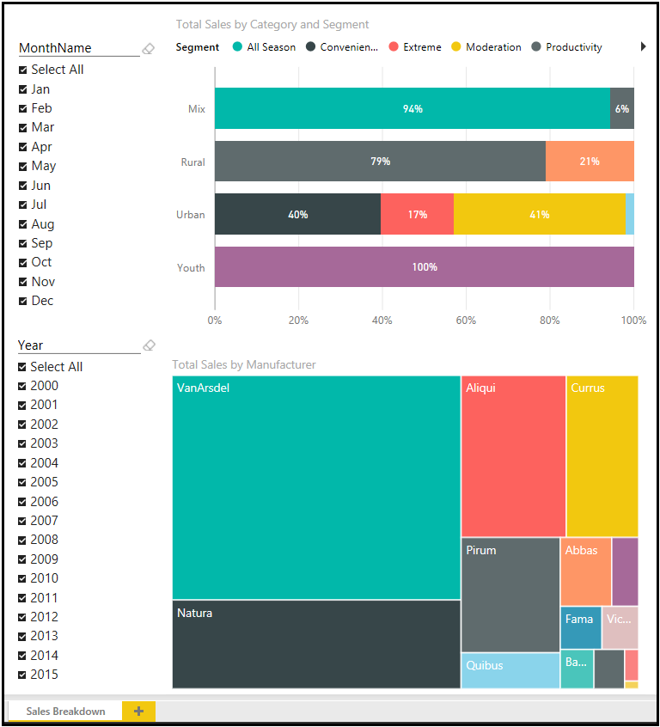

|  |
| --- |
| Lab 3.Exercise 3: Relationship Report |

You would like to know more about the relationship between total units and total sales by category and segment. You choose to analyze this using scatter chart.

1. Create a new report page by clicking the Yellow "+" icon at the bottom of the report view.
2. Create a chart based on the **Scatter Chart** visualization.
3. Drag the **Total Sales** and **Total Units** fields from the **Sales** table to the chart.
4. Drag the **Category**and **Segment** fields from the **Products** table to the chart.
5. Drag the **YTD Sales** field from the **Sales** table to the chart.
6. Drag the **Year**field from the **Date**table to the chart.
7. Ensure that the following fields are set in the visualization:
   1. **Details**: Category
   2. **Legend**: Segment
   3. **X Axis**: Total Sales
   4. **Y Axis**: Total Units
   5. **Size**: YTD Sales
   6. **Play Axis**: Year

You should have something similar to the below:

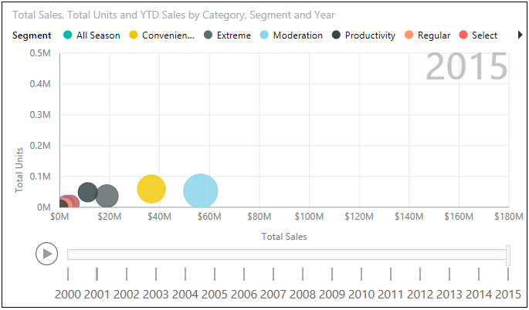

# Lab 3.Exercise 4: Trend Report

Let's do some trend analysis. First let's show a chart to compare Total Sales and Total Units throughout the years. And then let's show two more charts showing the Total Sales and Total Units variances throughout the years.

1. Create a new report page by clicking the Yellow "+" icon at the bottom of the report view.
2. Drag the **Year**field from the **Date**table to the report and create the first chart.
3. Drag the **Total Sales** and **Total Units** fields from the **Sales**table to the chart.
4. Modify the chart to use the **Line and Stacked Column Chart** visualization.
5. Ensure that the **Year**is shown as the **Shared Axis**, **Total** **Sales**is shown as the **Column values**, and **Total Units** is shown as the**Line values** of the visualization.
6. Create the second chart based on the **Waterfall Chart** visualization.
7. Drag the **Sales Var** field from the **Sales** table to the chart.
8. Drag the **Year**field from the **Date**table to the chart.
9. Create the third chart, also based on the**Waterfall Chart** visualization.
10. Drag the **Total Units Var** field from the **Sales** table to the chart.
11. Drag the **Year**field from the **Date**table to the chart.
12. Add a Text Box to the report and enter **Yearly Trend** as the text.
13. Rename the report sheet to**Yearly Trend.**

You should have something similar to the below:

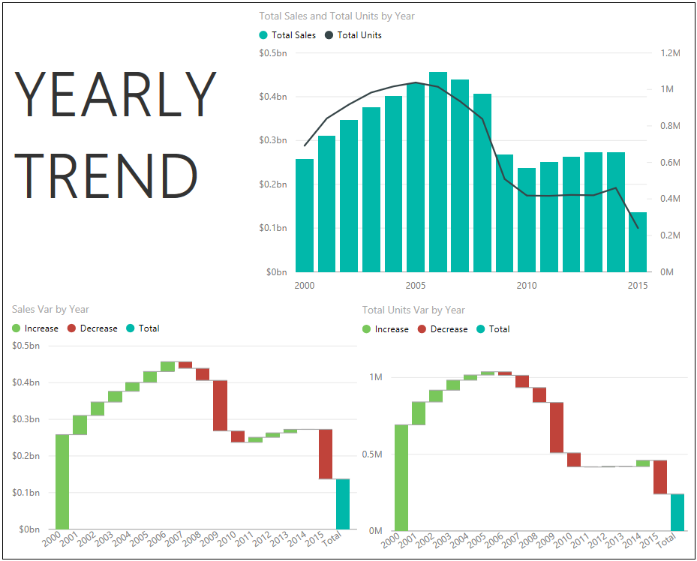

|  |
| --- |
| Lab 3.Exercise 5: Rank Report |

You now want to analyze individual products sales (revenue) and volume (units). You decide to show these using two bar charts.

1. Create a new report page by clicking the Yellow "+" icon at the bottom of the report view.
2. Drag the **Total Sales** field from the **Sales** table to the report and create a chart.
3. Drag the **Product**field from the **Products** table to the chart.
4. Modify the chart to use the **Bar Chart** visualization.
5. Ensure that the chart is sorted by **Total Sales**.
6. Drag the **Total Units**field from the **Sales**table to the report and create a chart.
7. Drag the **Product**field from the **Products** table to the chart.
8. Modify the chart to use the **Bar Chart** visualization.
9. Ensure that the chart is sorted by **Total Units**.
10. Drag the **Year** field from the **Date** table to the report and create a chart.
11. Modify the chart to use the **Slicer**visualization.
12. Add a Text Box to the report and enter **Top Products**as the text.
13. Rename the report sheet to **Top Products.**

You should have something similar to the below:

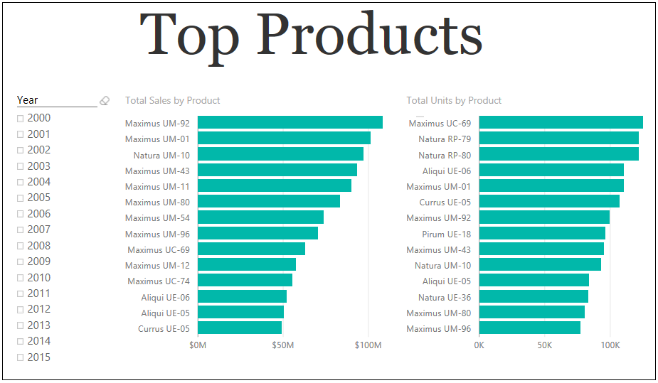

# Lab 4 Overview Power BI Service

## SCENARIO

VanArsdel is a company that manufactures and sells sporting goods. The company has offices in the United States (US) and several other countries. Its sales comprise of US sales and International sales. VanArsdel’s sales come from its owned manufactured products, as well as other manufacturers’ products.

You have created reports with VanArsdel's US and International sales data using Power BI Desktop. Now it's the time to use Power BI service to display this report, create a dashboard, share it, and set a scheduled refresh for the dataset.

## LAB OVERVIEW

In this lab, you will upload a Power BI Desktop report to Power BI service. You will then pin several visualizations and create a dashboard. You will also use the natural language queries feature to create and pin new visualizations. To top it off, you will share this newly created dashboard and set a scheduled refresh so that the dashboard is always up-to-date.

Before starting this lab, you should review **Power BI Service** module in this course. Then, if you have not already done so, follow the instructions in the **Set up the Lab Environment** section of this course to set up the lab environment.

WHAT YOU’LL NEED

* A computer with the latest version of Power BI Desktop installed on it.
* The following Power BI Desktop file:
* The “[Lab 4 - Starting.pbix](https://github.com/MicrosoftLearning/Analyzing-Visualizing-Data-PowerBI/raw/master/Lab4/Lab%204%20-%20Starting.zip)” file
* Power BI service account (You need to have a work / business email to sign up for Power BI service)

|  |
| --- |
| Lab 4.Exercise 1: Upload PBI Report and Pin Visualizations |

First, you will upload a Power BI Desktop file to Power BI Service.

1. Start with the "[Lab 4 - Starting.pbix](https://github.com/MicrosoftLearning/Analyzing-Visualizing-Data-PowerBI/raw/master/Lab4/Lab%204%20-%20Starting.zip)" file.
2. Use the **Publish** button to publish the report. Sign in using the account you used to sign up for Power BI service.
3. Once the report is published, go to [**http://www.powerbi.com**](http://www.powerbi.com/) and sign in using your account.
4. If this is your first time publishing a report to Power BI service, you will notice that you now have a dataset named **Lab 4 - Starting** and a report named **Lab 4 - Starting**. You can rename both of these, but let's just leave them be for now.
5. Go to the **Lab 4 - Starting Report** and explore your published report. It looks similar to the one in Power BI Desktop file. Now you can start creating a dashboard by pinning some visualizations.
6. Go to the **Sales Report** tab and pin the chart showing **Total Sales by Category and Segment** (100% Stacked Bar Chart). Select to create a **New dashboard** and name it **VanArsdel Sales**.
7. Pin the treemap chart, the scatter chart, and the map visualization to the **VanArsdel Sales** dashboard.
8. Go to the **Yearly Trend** tab and pin the waterfall chart that shows the **Sales Var by Year**.
9. Go to the **VanArsdel Sales** dashboard and review what you have created.
10. Resize and arrange the tiles as necessary.

You should have something similar to the below:

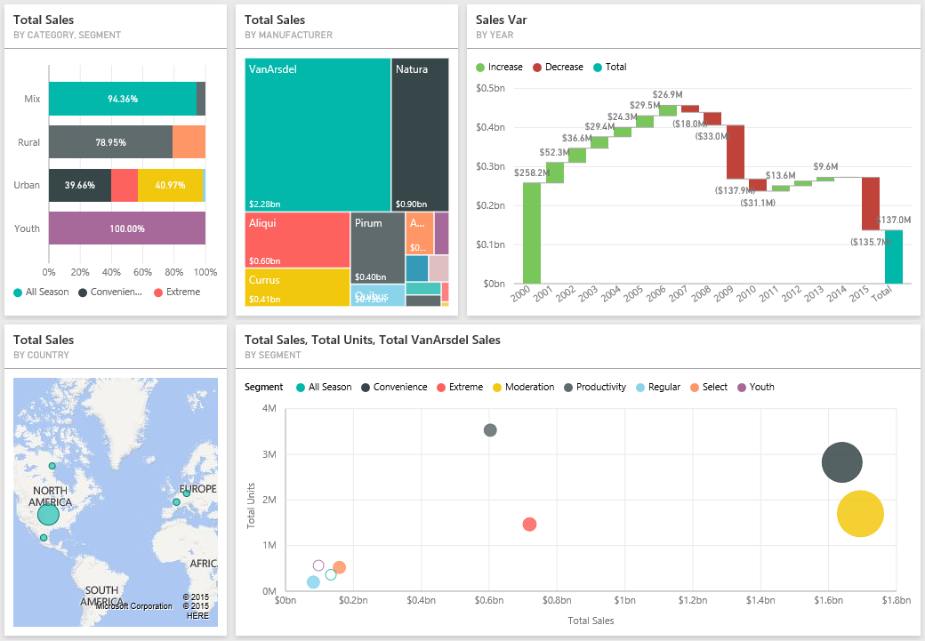

|  |
| --- |
| Lab 4.Exercise 2: Share Dashboard and Update Report |

Let's start sharing your newly created dashboard. For simplicity, let's share the dashboard to your own email address.

1. In the **VanArsdel Sales** dashboard, use the **Share** button to share your dashboard.
2. Enter your email address used for Power BI service and click **Share**.
3. Check your inbox to see an invite to view this dashboard.

# Lab 4.Exercise 3: Schedule Data Refresh

So far, the report you uploaded is rather static. That means, if the data in the Access database changes, the report and dashboard are not updated. You can install Power BI Personal Gateway and schedule data refresh for on-premises data sources, such as the Access database, to keep your report and dashboard on Power BI service up-to-date.

1. Go to the **Lab 4 - Starting**Datasets in Power BI service and click **Schedule Refresh**.
2. Power BI Pro is required to setup scheduled refresh for on-premises data. If you do not have Power BI Pro subscription you can enroll for a 60 day trial.
3. Ensure that you are in the **Datasets** tab and that the **Lab 4 - Starting** dataset is selected. Click **Install now**to download and install the Power BI Personal Gateway, accept the license terms, and wait for the installation to complete.
4. Launch the Gateway, sign in using your Power BI account and click **Finish**.
5. Edit credentials for the Data sources that needs updating.
6. Now you can schedule your data source refresh.

**NOTE:** To be able to actually refresh the data, please ensure that you have the files from previous labs under the "C:\DAT207x\" folder. This is because the files were developed with this referenced. You might use arbitrary folders in your own scenario.

|  |
| --- |
| Lab 5 Overview Working with Excel |

## SCENARIO

VanArsdel is a company that manufactures and sells sporting goods. The company has offices in the United States (US) and several other countries. Its sales comprise of US sales and International sales. VanArsdel’s sales come from its owned manufactured products, as well as other manufacturers’ products.

Some of your colleagues are using Excel as their primary reporting tool. You want to collaborate with them and use their Excel files using Power BI service.

LAB OVERVIEW

In this lab, you will upload Excel files to Power BI service. First, you will upload an Excel file containing an Excel table, and create quick visualizations based on that data. Next, you will upload an Excel file that contains an Excel data model and Power View report, and use the converted report in Power BI service. Before starting this lab, you should review **Working with Excel** module in this course. Then, if you have not already done so, follow the instructions in the **Set up the Lab Environment** section of this course to set up the lab environment.

WHAT YOU’LL NEED

* The following Excel files:
  + The “[Lab 5 - Canada.xlsx](https://github.com/MicrosoftLearning/Analyzing-Visualizing-Data-PowerBI/raw/master/Lab5/Lab%205%20-%20Canada.zip)” file
  + The “[Lab 5 - USA.xlsx](https://github.com/MicrosoftLearning/Analyzing-Visualizing-Data-PowerBI/raw/master/Lab5/Lab%205%20-%20USA.zip)” file

Power BI service account (You need to have a work / business email to sign up for Power BI service).

|  |
| --- |
| Lab 5.Exercise 1: Upload Excel File with an Excel Table |

 First, you will upload an Excel file containing an Excel table.

1. Download and extract the the “[Lab 5 - Canada.xlsx](https://github.com/MicrosoftLearning/Analyzing-Visualizing-Data-PowerBI/raw/master/Lab5/Lab%205%20-%20Canada.zip)” file. The file contain VanArsdel's Canada sales. If you have a Microsoft Excel installed, you can open and explore the file (you don't have to).
2. Go to [**http://www.powerbi.com**](http://www.powerbi.com/) and sign in using your account.
3. Click **Get Data**, select **Files** and click **Get**. Select **Local file** and **Import Excel data into Power BI**. The Excel file is imported as a Dataset in Power BI service.
4. Go to the **Lab 5 - Canada**Dataset.
5. Now, answer the following questions by creating visualizations using the skills you learned in the previous module.

|  |
| --- |
| Lab 5.Exercise 2: Upload an Excel File with a Data Model |

Now, let's upload an Excel file containing a Data Model and a Power View Report.

1. Download and extract the the “[Lab 5 - USA.xlsx](https://github.com/MicrosoftLearning/Analyzing-Visualizing-Data-PowerBI/raw/master/Lab5/Lab%205%20-%20USA.zip)” file. The file contain VanArsdel's USAsales. If you have a Microsoft Excel installed, you can open and explore the file (you don't have to).
2. Go to [**http://www.powerbi.com**](http://www.powerbi.com/) and sign in using your account.
3. Click **Get Data**, select **Files** and click **Get**. Select **Local file** and upload the Excel file. The Excel file is uploaded as a Dataset in Power BI service. Since this Excel file also contain a Power View report, the Power View report is converted to a Power BI report.
4. Go to the **Lab 5 - USA** Report.
5. Now, answer the following questions by reviewing the **Power View1** tab in the **Lab 5 - USA** Report.